Below is a chart of some signs that may help an Athletic Trainer identify an athlete who may be experiencing a mental health crisis (Mental Health Card).
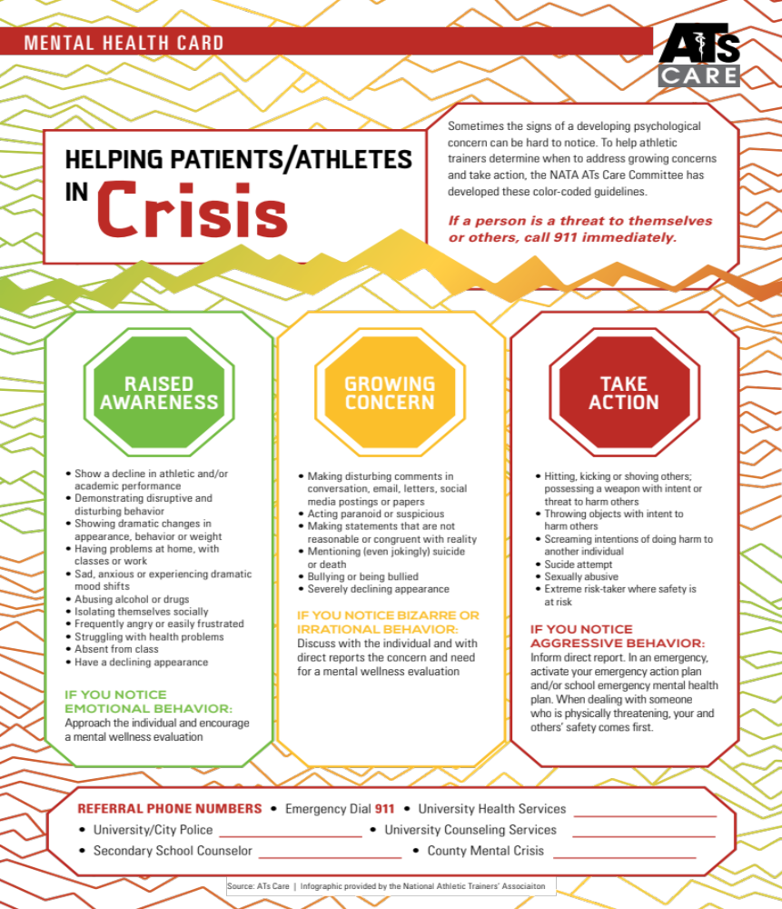
See Something Say Something Do Something

